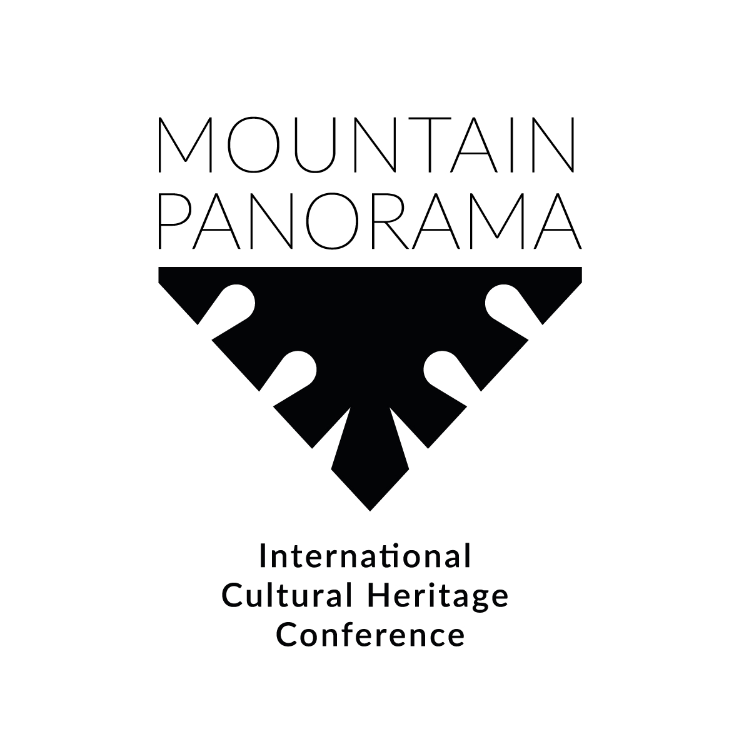

9th June, Thursday
(the main building of the Tatra Museum, Krupówki 10
the Museum of the Zakopane Style at Koliba villa, Kościeliska 18)
17.00-17.30 | Opening of the conference Mountain Panorama International Cultural Heritage Conference (curators: Anna Wende-Surmiak (the Tatra Museum Director), Rosalaura Romeo (Mountain Partnership Secretariat, FAO Rome), Aldo Audisio (International Projects Expert)) | THE MAIN BUILDING OF  THE TATRA MUSEUM, KRUPÓWKI 10
17.30 -18.00 | Opening lecture: prof. Dorota Folga-Januszewska (Academy of Fine Arts in Warsaw)  New / old functions of the museums in the contemporary world and museotherapy (Auditorium A)
18.30.19.15 | Guided tour: the Museum of the Zakopane Style at Koliba villa | THE MUSEUM OF THE ZAKOPANE STYLE AT KOLIBA VILLA, KOŚCIELISKA 18
19.15-20.00 | Opening of the exhibition Stele. Stone deities of Donato Savin. Artworks of the artist from the Aosta Valley.
20.00 | Cocktail party

10th June, Friday
(the main building of the Tatra Museum, Krupówki 10)
9.00 – 10.00 | Debate: MUSEUMS IN MOUNTAINOUS REGIONS mission and future: from tradition to innovation, new museum dimensions and new perspectives  Moderator: Giovanni Kezich (Trentino Ethnographic Museums Network)  Guests: Donna Livingstone (The Whyte Museum of the Canadian Rockies, Canada), Michelle Huwiler (Swiss Alpine Museum, Switzerland), Julita Izabela Zaprucka (The Karkonosze Mountain Museum, Poland), Anna Wende-Surmiak (The Tatra Museum, Poland)
 | SECTION A (AUDITORIUM A)  Moderator: Aleksandra Michalska | SECTION B (AUDITORIUM B)  Moderator: Marta Kula
10.00-10.20 | Luca Calzolari  Magazine Montagne360 – Italian Alpine Club  Talking about mountains and mountaineering in the era of social media | Michelle Huwiler  The Swiss Alpine Museum  Lost and Found for Memories: A participatory collection project that involves the public in collection decisions and advances the democratization of the Museum
10.20-10.40 | Krzysztof Trebunia-Tutka  The Tatra Cultural and Sports Centre Jutrzenka  Our shepherd's instruments | Daniela Reľovská, Dalibor Mikulík, Katarína Babčáková  The castle in Stara Ľubovňa  In the castle and open air museum in Ľubovňa
10.40-11.00 | Bernard Germain  The French Federation of Alpine and Mountain Clubs  Cinema’s view of the mountains | Magdalena Andreescu; Anamaria Iuga  The National Museum of the Romanian Peasant  A display, a museum, and a geopark in the Buzau mountain area
11.00-11.30 | Coffee break
11.30-11.50 | Maciej Krupa  independent researcher  Faces of the shelters of the past | Kinga Nędza-Sikoniowska  The Tatra Museum  Mountain themes in the renewed exhibition of the Kornel Makuszyński Museum in Zakopane
11.50-12.10 | Leonardo Bizzaro  independent researcher  Ski. Traditions and memories | Giovanni Kezich  Trentino Ethnographic Museums Network  Mountain Landscape as a man-made artifact: the Ethnographic Atlas of Trentino (Italy)
12.10-12.30 | Wojciech Szatkowski  The Tatra Museum  Malinowski, Boivin and Tatarka-the heritage of ski-extreme | Aleksander Robotycki  National Ethnographic Museum in Warsaw  Sale and news. Image of mountains from shop shelves
12.30-12.50 | Łukasz Lewkowicz  Maria Curie-Skłodowska University  Speleological activity of Tadeusz and Stefan Zwoliński | Aleksandra Trybuła, Marcin Warchałowski  The Tatra Museum  The Tytus Chałubiński collection – digitalisation and preventive conservation of the oldest collection of the Tatra Museum
12.50-13.10 | Roberto Mantovani  independent researcher  Alpine Clubs and the "conquest" of the mountains | Emilia Pomiankiewicz-Wagner  The Tatra Museum  Mountain Panorama – the Tatra Museum’s collection  from the inventory perspective

 | SECTION C (AUDITORIUM A)  Moderator: Kinga Nędza-Sikoniowska | SECTION D (AUDITORIUM B)  Moderator: Karolina Kula
14.45-15.05 | Maria Kościelniak-Woźniak  University of Wrocław  Emancipating from under the Tatra domination. The undiscovered and dispersed cultural potential of the Gorce Mountains | Cezary Kościelniak  Adam Mickiewicz University in Poznan  In search of the language of sustainable development in mountains. Discussing the heritage between sustainability and exploitation
15.05-15.25 | Piotr Kubkowski  University of Warsaw  The most important Polish landscape? The meaning of the Tatra Mountains in cultural practices of the Polish Country Lore Society (1906-1929) | Txomin Uriarte  Basque Mountaineering Museum  Mountain letter boxes  Preceded by a presentation of  Museo del Montañismo Vasco – Emmoa - Vitoria-Gasteiz
15.25.-15.45 | Svetlana Belova, Jozef Bednar  Association for nature conservation Machaon International  The future of Tatras: mountainous nature or faceless suburbs? | Stanisława Trebunia-Staszel  Jagiellonian University  The Cross on the Giewont Hill in the Tatra Mountains. Between traditional values and activism. Negotiating cultural heritage
15.45-16.05 | Julia Salamądry  University of Wrocław  The Inscription of Sacred Mountains on the UNESCO World Heritage List | Carles Capellas  Mountain General Information Service  The General Mountain Information Service, an alpine documentation center at the service of the international alpine community  Preceded by a presentation of  Servei General d'Informacio de Muntanya -Sabadell  in cooperation with Federació d'Entitats Excursionistes de Catalunya
16.05-16.25 | Katarzyna Kerneder-Gubała  The Institute of Archaeology and Ethnology Polish Academy of Sciences  Siliceous rocks of the mountainous regions and their importance for the Stone Age communities. An outline of the issue | Eduardo Erazo Acosta  High Mountains  University Nariño, in Pasto city
17.00-18.15 | DEBATE 2: ALLIES OF THE MOUNTAINS  Gathered to promote the highlands of the planet, from culture to sustainable development in the context of the International Year of Sustainable Mountain Development  Moderator: Aldo Audisio (international projects expert)  Guests: Rosalaura Romeo (Mountain Partnership, FAO Rome), Angelo Schena (IAMF - International Alliance for Mountain Film), Nahuel Uria (RED-FAP Red de Festivales Audiovisuales Patagónicos), Miłosz Jodłowski (Polski Związek Alpinizmu), Emilia Pomiankiewicz-Wagner (IMMA – International Mountain Museums Alliance)

11th June, Saturday
(the main building of the Tatra Museum, Krupówki 10)
 | SECTION E (AUDITORIUM A)  Moderator: Emilia Pomiankiewicz-Wagner | SECTION E (AUDITORIUM A)  Moderator: Emilia Pomiankiewicz-Wagner
9.00-9.20 | Katarzyna Chrudzimska-Uhera  Cardinal Stefan Wyszyński University in Warsaw  Woodcarving in Podhale and the phenomenon of the "School in Zakopane” sculptures | Maria Małanicz-Przybylska  University of Warsaw  Between tangible and intangible – heritage of wooden houses in Chochołów
9.20-9.40 | Marcella Fratta  Councilor for Culture Municipalities of Sondrio  Sondrio city of mountain culture | Natalia Skiepko  The Tatra Museum  Heritage locked in the cottage. Folk architecture of the Podhale and Tatra Mountains region
9.40-10.00 | Barbara Caillot  independent researcher  The legendary white bear of Zakopane | Paulina Lis-Meldner  Warsaw University of Technology, Faculty of Architecture  Beyond picturesque clichés – a modern house in the mountains
10.15-11.45 | DEBATE 3: Mountains everywhere  from specialized magazines to daily newspapers, and new media  Moderator: Bernard Germain (Montagne & Alpinisme magazine)  Guests: Luca Calzolari (Montagne 360 magazine), Agnieszka Szymaszek (Tatry magazine), Maciej Kwaśniewski (Taternik magazine), Leonardo Bizzaro (newspaper journalist), Roberto Mantovani (journalist and historian)
20.00 | Concert (two folk music bands: Trebunie-Tutki from Zakopane (Poland) and Quintet Urmuli from Tbilisi (Georgia) will perform the album Spirit of the Mountains)

